HowTo update the Python interpreter

1) Download the required Python version as full installer. The embedded package does not come with the Python.h and libraries
2) Install python into a temporary directory. Choose the custom installation and select the minimal optional features:
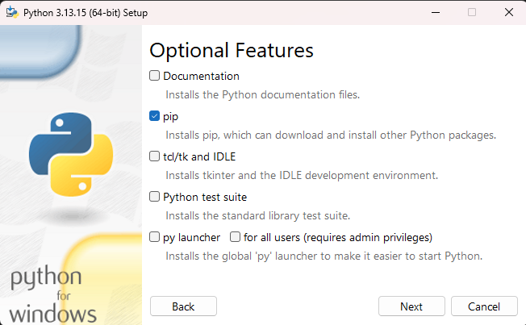
The precompile standard library creates .pyc files for each stl module. These compilation artifacts are usually created when they are imported the first time. Creating them in advance speeds up the import (not the execution). The auto cached files are stored at the location of the stl, which may not be possible due to the users write permission. Insufficient permissions will result a recompilation, every time the module is imported the first time (first run of the pythonExecution will be slow).
Using the precompile standard library option makes the speedup available at least for the same architecture/OS environment.
ToDo: There is an option to change the PyCache directory: PYTHONPYCACHEPREFIX=/path/to/cache. Needs to be set in the Interpreter startup.
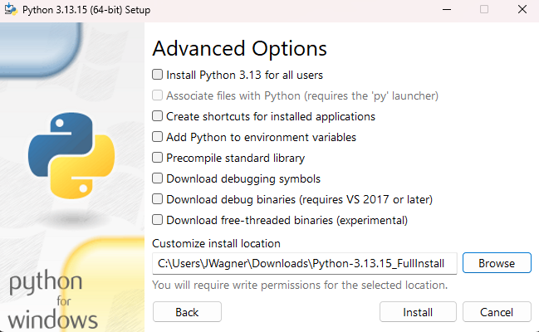

Downloading the debugging symbols really doesn’t help that much. This may allow the execution of the interpreter with the stl in debug mode, but additional packages also need to be built with debugging symbols, otherwise they will clash with the interpreter. Building the packages in debug is a big hassle. And debugging the execution of a script will require every involved package to be accessible with debug symbols. Thus, we do not use the debug build at the moment.
! The installation is meant to be a temporal folder, which we restructure so that it will be suitable for the Thirdparty directory. Be careful not to create any system path entries or similar. The shown, minimal, setup prevents such system wide settings and keeps the installed temporal directory mostly isolated. However, a registry entry for the installation/deinstallation will still be created.
3) Setup a folder structure for the new version in the third party repository.
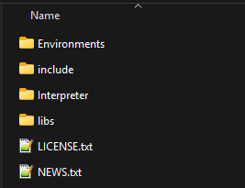
The folder Interpreter and libs are getting the subfolder Debug and Release, so that the linker path variables can be chosen in the common format (e.g.: OT_Python/OT_LIBD). However, both, OT_LIBD and OT_LIBR will have to point to the Release build, as formerly discussed.
In the Environments folder add the following subfolders:
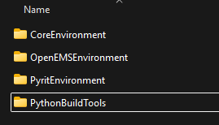
4) From the temporary installation folder move the content to the Third Party directory as described. The temporal folder will be named Temp/ and the Third-Party folder will be named Target/ :
A - Into the Target/Interpreter/Release folder move the interpreter executables from Temp/ :
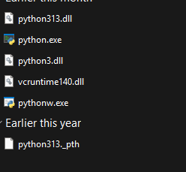
If no _pth file exists, create one for the purpose of testing. This file overwrites the internal path logic of the interpreter. Add these lines:
../../Environments/PythonBuildTools
../../Environments/CoreEnvironment/Lib
../../Environments/CoreEnvironment/DLLs/Release
../../Environments/PyritEnvironment
import site

Also create a <pythonBinName>_release._pth with this content:
./
PythonEnvironments/PythonBuildTools
PythonEnvironments/CoreEnvironment/Lib
PythonEnvironments/CoreEnvironment/DLLs
PythonEnvironments/PyritTests
import site
<pythonBinName> needs to correspond to the name of the interpreters versions dll. In this case <pythonBinName> = python313

B- Into the Target/libs/Release folder move the Temp/lib files:
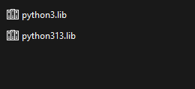

C- Into the Target/include folder move the Temp/include files
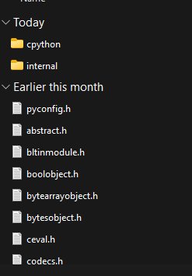
… There are more in the folder. About 70/80 files. Move them all.

D- Into the Target/CoreEnvironment/DLLs/Release move Temp/DLLs
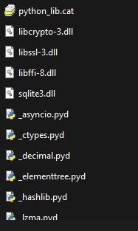 Here as well, there are many files. Move them all.

E- Into the Target/Environments/CoreEnvironment/Lib move the content from Temp/Lib
F – Into Target/Environments/PythonBuildTools move Temp/Environments/CoreEnvironment/Lib/side-packages/pip and Temp/Environments/CoreEnvironment/Lib/side-packages/pip-*.dist-info. Remove the site-package folder.
5) Test run:
EXEC: Change into the Interpreter/Release directory. From a cmd execute python.exe
EXPECT: Python interpreter starts with no error message (nothing like, “could not find module”)

EXEC: Run “import sys” then “sys.exit()”
EXPECT: Interpreter ends

SETUP: Add into the ._pth file: “../../Environments/Temp”
EXEC:
- Run .\python.exe -m pip install numpy --target=< TargetPath>/Environments/Temp
- Run the interpreter with .python.exe
- Execute the following:

import numpy as np
n_array = np.array([[6,-1.7], [30, 44]])
det = np.linalg.det(n_array)
print(int(det))
EXPECT:
- Only the directory Temp/Environments/Temp has changed
- Numpy can be imported
- The execution succeeds (determinant = 315)

6) Install required packages

7) Change the environment virables:
- OT_CURRENT_PYTHON_PATH environment variable to point to the new ThirdParty folder
- SET OT_PYTHON_BIN_NAME to match the common name of .lib, .dll and ._pth file.

